**VETRI IT SYSTEMS PRIVATE LIMITED**

**PROJECT REPORT**

**PROJECT TITLE: DEE Plus Meditation**

**1. Project Overview**

**Project Name:**Dee Plus Meditation  
**Project Assigned Date:** [18-08-2025]  
**Planned Completion Date:** [24-08-2025]  
**Delivery Date:** [24-08-2025]

**2. Project Team**

* **Project Manager:** Maheshwaran
* **Designer:** Malathy
* **Developer(s):** Vijayalakshmi N
* **Testing Team:** Yogavarshini

**3. Technology Stack**

* **Frontend Technologies:**HTML, CSS, Javascript

**4. Project Scope**

Through evidence-based meditation and mindfulness tools, mental health, coaching, therapy, psuchiatry, headspace helps you create life-changing, habits to support your mental health and find a healthier, happier you.

**Key Objectives:**

* Reducing Stress and Anxiety
* Enhancing focus and clarity
* Empowering emotional regulations
* Promoting Self-awareness

**5. Project Modules**

* **Home**
* **Therapy**
* **About us**
* **Meditation**
* **Contact**

1. **Project Code**

**Frontend Code (HTML):**

<!DOCTYPE html>

<html lang="en">

<head>

  <meta charset="UTF-8">

  <meta name="viewport" content="width=device-width, initial-scale=1">

  <title>Dee Plus Navbar</title>

  <link rel="stylesheet" href="https://cdnjs.cloudflare.com/ajax/libs/font-awesome/7.0.0/css/all.min.css" integrity="sha512-DxV+EoADOkOygM4IR9yXP8Sb2qwgidEmeqAEmDKIOfPRQZOWbXCzLC6vjbZyy0vPisbH2SyW27+ddLVCN+OMzQ==" crossorigin="anonymous" referrerpolicy="no-referrer" />

  <!-- Bootstrap CSS -->

  <link href="https://cdn.jsdelivr.net/npm/bootstrap@5.3.3/dist/css/bootstrap.min.css" rel="stylesheet">

  <!-- Bootstrap Icons -->

  <link href="https://cdn.jsdelivr.net/npm/bootstrap-icons@1.10.5/font/bootstrap-icons.css" rel="stylesheet">

  <link rel="preconnect" href="https://fonts.googleapis.com">

  <link rel="preconnect" href="https://fonts.gstatic.com" crossorigin>

  <link href="https://fonts.googleapis.com/css2?family=Nosifer&display=swap" rel="stylesheet">

  <link rel="stylesheet" href="style.css">

</head>

<body>

<!-- Navbar -->

<nav class="navbar navbar-expand-lg navbar-custom">

  <div class="container-fluid">

    <div class="d-flex align-items-center">

      <div class="logo-text me-5">

        <h1>DEE</h1>

        <h1>PLUS</h1>

      </div>

    </div>

    <button class="navbar-toggler" type="button" data-bs-toggle="collapse" data-bs-target="#navbarNav">

      <span class="navbar-toggler-icon"></span>

    </button>

    <div class="collapse navbar-collapse justify-content-between" id="navbarNav">

      <ul class="navbar-nav ms-5">

        <!-- Home link with the 'active' class -->

        <li class="nav-item"><a class="nav-link active" href="#">Home</a></li>

        <li class="nav-item"><a class="nav-link" href="#">Therapy</a></li>

        <li class="nav-item"><a class="nav-link" href="#">About Us</a></li>

        <li class="nav-item"><a class="nav-link" href="#">Meditation</a></li>

        <li class="nav-item"><a class="nav-link" href="#">Contact Us</a></li>

      </ul>

      <div class="d-flex">

        <a class="nav-link" href="#"><i class="bi bi-search text-white" aria-label="Search"></i></a>

        <a class="nav-link" href="#"><i class="bi bi-person text-white" aria-label="User Profile"></i></a>

      </div>

    </div>

  </div>

</nav>

  <!-- Image container with button -->

<div class="image-container">

    <button class="join-button">Join Now</button>

  </div>

  <!--Dee Plus Stands for-->

    <div class="header">

    What DEE PLUS <span style="color: white;">Stands For</span>

  </div>

  <div class="container">

    <div class="row content">

      <!-- Left Column -->

      <div class="col-md-6 left-column">

        <h4>M Mindfulness</h4>

        <p>Being aware of the present</p>

        <h4>E Equanimity</h4>

        <p>Calm and balanced emotions</p>

        <h4>D Discipline</h4>

        <p>Consistency in practice</p>

        <h4>I Inner Peace</h4>

        <p>A state of deep tranquility</p>

        <h4>T Tranquility</h4>

        <p>Soothing the restless mind</p>

        <h4>A Awareness</h4>

        <p>Conscious observation without reaction</p>

        <h4>T Transformation</h4>

        <p>Gradual personal growth</p>

        <h4>I Intention</h4>

        <p>Clarity of purpose</p>

        <h4>O Observation</h4>

        <p>Watching thoughts without Control</p>

        <h4>N Now</h4>

        <p>Anchoring yourself in the present moment</p>

      </div>

      <!-- Right Column (Image) -->

      <div class="col-md-6 right-column">

        <img src="Assets/a-man-practicing-yoga-removebg.png" alt="Meditating Person"> <!-- Replace with your image URL -->

        <div class="bottom-text">

            <h3>In Therapy Helps With</h3>

            <p>Reducing Stress and Anxiety</p>

            <p>Enhancing Focus and Clarity</p>

            <p>Improving Emotional Regulations</p>

            <p>Promoting Self-awareness</p>

      </div>

      </div>

    </div>

  </div>

<!--Meet Our Team-->

 <div class="container-custom">

    <div class="container background-image pt-4">

      <div class="row align-items-center mx-3">

        <!-- Left column with image -->

        <div class="col-md-6">

          <img src="Assets/istockphoto-1445245272-612x612.jpg" alt="Group of hands" class="hero-image">

        </div>

        <!-- Right column with title and button -->

        <div class="col-md-6 text-center">

          <p style="text-align: left; font-size: 25px;">Welcome to</p>

          <h1 class="text-center" style="color: purple; font-weight: 700;">Private Psychiatry<br> & Therapy Clinic</h1>

          <p class="lead">

            A specialized healthcare facility offering confidential, personalized mental health services, including psychiatric evaluations, medication management, and psychotherapy. Designed to provide discreet, compassionate care for individuals seeking support for emotional, behavioral, or psychological challenges.

          </p>

          <a href="#team" class="btn meet mt-4">Meet Our Team</a>

        </div>

      </div>

      <!-- Stats Section (aligned at bottom) -->

      <div class="row stats-container mt-5">

        <div class="col-md-3 stat-box">

          <h3>1586</h3>

          <p>Sessions Per Year</p>

        </div>

        <div class="col-md-3 stat-box">

          <h3>20</h3>

          <p>Years Experience</p>

        </div>

        <div class="col-md-3 stat-box">

          <h3>5000+</h3>

          <p>Successful Therapy</p>

        </div>

        <div class="col-md-3 stat-box">

          <h3>18</h3>

          <p>Specialists in Our Team</p>

        </div>

      </div>

    </div>

  </div>

  <!--Therapy Cards-->

  <h1 style="color: purple; font-size: 30px; font-weight: bold; text-align: center;">Our Services</h1>

<div class="container-therapy">

        <div class="card" >

            <h2>Individual Therapy</h2>

            <div class="d-flex justify-content-between align-items-center"><a href="#">Read more</a>

            <img src="Assets/sing_man_remvbg.png" alt="Individual Therapy" width="50"></div>

        </div>

        <div class="card-img">

        </div>

        <div class="card blue">

            <h2 style="color: white;">Couples Therapy</h2>

            <div class="d-flex justify-content-between align-items-center"><a href="#" style="color: #e3ffd4;">Read more</a>

            <img src="Assets/two_people.png" alt="Individual Therapy" width="50" style="filter: invert(1);"></div>

        </div>

        <div class="card">

             <h2>Group Therapy</h2>

            <div class="d-flex justify-content-between align-items-center"><a href="#">Read more</a>

            <img src="Assets/group-of-people-icon-simple-outline-style-staff-crowd-people-organisation-management-group-meeting-man-business-team-teamwork-concept-thin-line-symbol-illustration-isolated-vector.jpg" alt="Individual Therapy" width="80"></div>

        </div>

        <div class="card-img1">

        </div>

        <div class="card">

            <h2>Family Therapy</h2>

            <div class="d-flex justify-content-between align-items-center"><a href="#">Read more</a>

            <img src="Assets/family-outline-icon-vector-isolated-line-illustration-188059698.jpg" alt="Individual Therapy" width="80"></div>

        </div>

        <div class="card-img2">

        </div>

        <div class="card">

            <h2>Online Therapy</h2>

            <div class="d-flex justify-content-between align-items-center"><a href="#">Read more</a>

            <img src="Assets/laptop-mobile-pc-line-icon-260nw-2584977643.jpg" alt="Individual Therapy" width="80"></div>

        </div>

    </div>

      <div class="container-fluid position-relative testimonial-container mt-5">

    <!-- Arrows -->

    <div class="arrow-left arrows">&#10094;</div>

    <div class="arrow-right arrows">&#10095;</div>

    <!-- Title -->

    <p class="testimonial-title">Testimonials</p>

    <h2 class="testimonial-heading">What Our Clients Says</h2>

    <!-- Profile Image -->

    <div class="d-flex justify-content-center mt-4 position-absolute" style="right: 200px; top: 50px;">

      <img src="https://randomuser.me/api/portraits/men/32.jpg" alt="Client Photo" class="profile-img" />

    </div>

    <!-- Pagination Dots -->

    <div class="pagination-dots">

      <div class="dot active"></div>

      <div class="dot"></div>

      <div class="dot"></div>

      <div class="dot"></div>

    </div>

  </div>

<div class="container-fluid py-5">

    <div class="section-title">

      <p style="font-size: 25px;">Meet Our Therapist</p>

      <h2>Our Team</h2>

    </div>

    <div class="container mt-4 position-relative">

      <div class="d-flex justify-content-end gap-3 mb-3">

        <button class="arrow-btn">&#8592;</button>

        <button class="arrow-btn">&#8594;</button>

      </div>

      <div class="row gy-4">

        <!-- Card 1 -->

        <div class="col-sm-6 col-md-6 col-lg-3">

          <div class="card-team">

            <img src="https://images.pexels.com/photos/774909/pexels-photo-774909.jpeg" alt="Jansi Merry" />

            <div class="card-body text-center">

              <h5 class="mb-2">JansiMerry</h5>

              <p class="mb-3">Clinical Director / Psychologist</p>

            </div>

          </div>

        </div>

        <!-- Card 2 -->

        <div class="col-sm-6 col-md-6 col-lg-3">

          <div class="card-team">

            <img src="https://images.pexels.com/photos/13373661/pexels-photo-13373661.jpeg" alt="Rizza" />

            <div class="card-body text-center">

              <h5 class="mb-2">Rizza</h5>

              <p class="mb-3">Psychologist</p>

            </div>

          </div>

        </div>

        <!-- Card 3 -->

        <div class="col-sm-6 col-md-6 col-lg-3">

          <div class="card-team">

            <img src="https://images.pexels.com/photos/1704488/pexels-photo-1704488.jpeg" alt="John Smith" />

            <div class="card-body text-center">

              <h5 class="mb-2">john Smith</h5>

              <p class="mb-3">Clinical Director / Psychologist</p>

            </div>

          </div>

        </div>

        <!-- Card 4 -->

        <div class="col-sm-6 col-md-6 col-lg-3">

          <div class="card-team">

            <img src="https://images.pexels.com/photos/3777945/pexels-photo-3777945.jpeg" alt="Brady John" />

            <div class="card-body text-center">

              <h5 class="mb-2">Brady John</h5>

              <p class="mb-3">Psychologist</p>

            </div>

          </div>

        </div>

      </div>

      <!-- Pagination Dots -->

      <div class="pagination-dots1">

        <div class="dot1"></div>

        <div class="dot1"></div>

        <div class="dot1"></div>

        <div class="dot1"></div>

        <div class="dot1"></div>

      </div>

    </div>

</div>

  <div class="container-fluid">

    <div class="section-title">

      <p style="font-size: 25px;">From the Blog</p>

      <h2>Latest Articles</h2>

    </div>

    <div class="container-fluid mt-4">

      <div class="row gy-4" style="gap: 70px; margin-left: 100px;" >

        <!-- Article 1 -->

        <div class="col-md-3">

          <div class="card-article">

            <img src="Assets/Occupation-therapy-1.jpg" alt="Article 1" />

            <div class="card-body text-center p-3">

              <p>News | April 21 2025</p>

              <h5>"Therapy Isn’t Just for Crisis—Here’s Why It Matters Every Day"</h5>

              <p>Read more</p>

            </div>

          </div>

        </div>

        <!-- Article 2 -->

        <div class="col-md-3">

          <div class="card-article">

            <img src="Assets/couples-therapist-1080x675.jpeg" alt="Article 2" />

            <div class="card-body text-center p-3">

              <p>News | April 14 2025</p>

              <h5>"Can Online Therapy Be as Effective? Here’s What Research Says"</h5>

              <p>Read more</p>

            </div>

          </div>

        </div>

        <!-- Article 3 -->

        <div class="col-md-3">

          <div class="card-article">

            <img src="Assets/Trauma-therapy.jpg" alt="Article 3" />

            <div class="card-body text-center p-3">

              <p>News | April 02 2025</p>

              <h5>"Breaking the Stigma: Why Seeing a Therapist Is a Strength"</h5>

              <p>Read more</p>

            </div>

          </div>

        </div>

      </div>

    </div>

</div>

  <section class="faq-section">

    <div class="container">

      <h2 class="faq-title">FAQs</h2>

      <div id="faqAccordion">

        <!-- FAQ 1 -->

        <div class="accordion-item">

          <h2 class="accordion-header" id="faqOne">

            <button class="accordion-button" type="button" data-bs-toggle="collapse" data-bs-target="#collapseOne" aria-expanded="true" aria-controls="collapseOne">

              1. How do I know if I need therapy?

              <span>-</span>

            </button>

          </h2>

          <div id="collapseOne" class="accordion-collapse collapse show" aria-labelledby="faqOne" data-bs-parent="#faqAccordion">

            <div class="accordion-body">

              If you're feeling overwhelmed, anxious, low, or stuck—or simply want to better understand yourself—therapy can help. You don’t need a crisis to benefit from mental health support.

            </div>

          </div>

          <div class="line-separator"></div>

        </div>

        <!-- FAQ 2 -->

        <div class="accordion-item">

          <h2 class="accordion-header" id="faqTwo">

            <button class="accordion-button" type="button" data-bs-toggle="collapse" data-bs-target="#collapseTwo" aria-expanded="false" aria-controls="collapseTwo">

              2. What is mental wellness?

              <span>+</span>

            </button>

          </h2>

          <div id="collapseTwo" class="accordion-collapse collapse" aria-labelledby="faqTwo" data-bs-parent="#faqAccordion">

            <div class="accordion-body">

              Mental wellness refers to your emotional, psychological, and social well-being. It affects how we think, feel, and act. It’s essential for overall well-being and can be nurtured with therapy and self-care.

            </div>

          </div>

          <div class="line-separator"></div>

        </div>

        <!-- FAQ 3 -->

        <div class="accordion-item">

          <h2 class="accordion-header" id="faqThree">

            <button class="accordion-button" type="button" data-bs-toggle="collapse" data-bs-target="#collapseThree" aria-expanded="false" aria-controls="collapseThree">

              3. What types of therapy do you offer?

              <span>+</span>

            </button>

          </h2>

          <div id="collapseThree" class="accordion-collapse collapse" aria-labelledby="faqThree" data-bs-parent="#faqAccordion">

            <div class="accordion-body">

              We offer individual, couples, and group therapy. Additionally, we specialize in cognitive behavioral therapy (CBT), mindfulness-based therapy, and trauma-focused therapy.

            </div>

          </div>

          <div class="line-separator"></div>

        </div>

        <!-- FAQ 4 -->

        <div class="accordion-item">

          <h2 class="accordion-header" id="faqFour">

            <button class="accordion-button" type="button" data-bs-toggle="collapse" data-bs-target="#collapseFour" aria-expanded="false" aria-controls="collapseFour">

              4. What can I expect in a therapy session?

              <span>+</span>

            </button>

          </h2>

          <div id="collapseFour" class="accordion-collapse collapse" aria-labelledby="faqFour" data-bs-parent="#faqAccordion">

            <div class="accordion-body">

              During a therapy session, you can expect a safe and non-judgmental space to explore your thoughts and feelings. A licensed therapist will help guide you through self-reflection and work with you to develop coping strategies.

            </div>

          </div>

          <div class="line-separator"></div>

        </div>

      </div>

    </div>

  </section>

<!-- Footer -->

<footer class="footer-custom text-center text-lg-start mt-5">

  <div class="container-fluid text-center text-md-start">

    <div class="row">

      <!-- Logo -->

      <div class="col-md-2 mb-4">

        <div class="logo-text1 me-5">

          <h1>DEE</h1>

          <h1>PLUS</h1>

        </div>

      </div>

      <!-- Links -->

      <div class="col-md-2 mb-4">

        <h6>Home</h6>

        <p>Happiness Week</p>

        <p>About Us</p>

        <p>Contact Us</p>

        <p>Course</p>

        <p>Meditation</p>

      </div>

      <div class="col-md-2 mb-4">

        <h6>Quick links</h6>

        <p>FAQ</p>

        <p>Terms & Conditions</p>

        <p>Help Center</p>

        <p>Partnership</p>

      </div>

      <!-- Opening Time -->

      <div class="col-md-3">

        <h6>Opening Time</h6>

        <p>Monday - Sunday</p>

        <p>9.00 AM To 9.00 PM</p>

      </div>

      <!-- Contact -->

      <div class="col-md-3 mb-4">

        <h6><i class="bi bi-geo-alt footer-icon"></i>Contact:</h6>

        <p style="margin-left: 20px;">6, Hethendran Street,<br>Kongu Nagar,<br>Karur - 26</p>

        <p><i class="bi bi-telephone footer-icon"></i>+9532 32556</p>

        <p><i class="bi bi-envelope footer-icon"></i><a href="#" style="text-decoration: none; color: white;">deepluswell@gmail.com</a></p>

      </div>

    </div>

  </div>

  <!-- Footer Logo (Attached to bottom) -->

  <img src="Assets/yoga_day.png" alt="Logo" class="footer-logo">

</footer>

<!-- Bootstrap JS -->

<script src="https://cdn.jsdelivr.net/npm/bootstrap@5.3.3/dist/js/bootstrap.bundle.min.js"></script>

</body>

</html>

**Frontend Code (CSS):**

body{

    background-color: #feeeee;

    font-family: Georgia, 'Times New Roman', Times, serif;

    scroll-behavior: smooth;

}

a{

    text-decoration: none;

    color: black;

}

/*Navbar*/

.navbar-custom {

      background-color: #B285C0; /* purple */

      border-radius: 30px;

      padding: 0.5rem 2rem;

      margin: 2rem auto 1rem auto;

    }

    .logo-text h1 {

      font-family: 'Nosifer', sans-serif;

      color: white;

      font-size: 1.5em;

      margin: 0.2em;

    }

    .logo-text1 h1 {

      font-family: 'Nosifer', sans-serif;

      color: white;

      font-size: 2.5em;

      margin: 0.2em;

    }

    .nav-link {

      color: white;

      font-size: 25px;

      margin: 0 30px;

    }

    .nav-link:hover, .nav-link.active:hover{

      color: rgb(236, 240, 22) !important;

    }

    /* Active nav link color */

    .nav-link.active {

      color: purple !important; /* Set the active color */

    }

    /*Footer*/

    .footer-custom {

      background-color: #B285C0;

      color: white;

      padding: 1rem 1rem;

      border-radius: 30px;

      margin-top: 2rem;

      position: relative; /* Ensures absolute positioning of logo inside */

    }

    .footer-icon {

      font-size: 1rem;

      vertical-align: middle;

      margin-right: 5px;

    }

    .footer-logo {

      width: 100px;

      height: 100px;

      font-size: 25px;

      position: absolute; /* Absolute positioning */

      bottom: -15px; /* Stick the logo at the bottom of the footer */

      left: 57%; /* Center it horizontally */

      transform: translateX(-50%); /* Ensure perfect centering */

    }

    .footer-custom .row > div {

      padding-bottom: 0.5rem;

    }

    .footer-custom h6 {

      margin-bottom: 0;

      font-size: 25px;

      line-height: 25px;

    }

    .footer-custom p {

      font-size: 25px;

      margin-bottom: 0;

      line-height: 25px;

    }

     /* Container for the image */

    .image-container {

      position: relative;

      background-image: url('Assets/1920_whatare10benefitsofmeditation.jpg'); /* Replace with your image URL */

      background-size: cover;

      background-position: center;

      height: 70vh; /* Adjust the height as needed */

      display: flex;

      justify-content: center;

      align-items: center;

      padding: 20px;

      border-radius: 15px;

      margin: 20px 50px 20px 50px;

    }

    /* Button styling */

    .join-button {

      background: linear-gradient(90deg, #9113f1,#1050ae); /* Gradient color for button */

      color: black;

      padding: 10px ;

      width: 200px;

      font-size: 25px;

      font-weight: bold;

      border: none;

      border-radius: 30px;

      cursor: pointer;

      position: absolute;

      bottom: 25%;

      right: 25%;

      transition: background 0.3s ease;

    }

    /*Dee Plus Stands for*/

    .header {

      text-align: center;

      color: purple; /* Dark purple */

      font-size: 36px;

      margin-top: 30px;

      font-weight: 900;

    }

    .content {

      display: flex;

      justify-content: space-between;

      align-items: center;

      margin-top: 50px;

    }

    .left-column {

      text-align: center;

      line-height: 15px;

    }

    .left-column h4 {

      font-size: 25px;

      color: purple; /* Dark purple */

      font-weight: bold;

    }

    .left-column p {

      font-size: 25px;

      color: black;

      margin-bottom: 25px;

    }

    .right-column img {

      width: 100%;

      height: 100%;

      border-radius: 15px;

    }

    .bottom-text h3 {

      font-size: 30px;

      color: purple; /* Dark purple */

      font-weight: bold;

      margin-bottom: 15px;

    }

    .bottom-text p {

      font-size: 25px;

      color: black;

      margin-bottom: 15px;

    }

    .bottom-text {

      text-align: center;

      line-height: 20px;

      margin-top: 10px;

    }

    /*Meet our Team*/

     .container-custom {

      padding: 50px 0;

    }

    .background-image{

      background-image: url(Assets/pastel-green-watercolor-background-free-vector.jpg);

      background-repeat: no-repeat;

      background-size: cover;

    }

    .hero-image {

      width: 100%;

      height: 100%;

      object-fit: cover;

    }

    .lead{

      font-size: 25px;

    }

    .stats-container{

      background-color: #5a8d92;

    }

    .stat-box {

      text-align: center;

      padding: 20px;

    }

    .stat-box h3 {

      font-size: 2rem;

      font-weight: bold;

    }

    .stat-box p {

      font-size: 1rem;

    }

    .meet {

      background: linear-gradient(90deg, #9113f1,#1050ae);

      color: black;

      font-size: 30px;

      font-weight: 700;

      padding: 10px 20px;

      text-decoration: none;

      border-radius: 40px;

    }

    /*Therapy Cards*/

    .container-therapy {

    display: grid;

    grid-template-columns: repeat(4, 300px);

    padding: 20px;

    gap: 20px;

    margin: 0 100px 0 100px;

}

.card {

    background-color: #fff;

    border-radius: 20px;

    box-shadow: 0 4px 6px rgba(0, 0, 0, 0.1);

    padding: 20px;

    text-align: center;

    transition: transform 0.3s;

    width: 300px;

    height: 300px;

    display: flex;

    flex-direction: column;

    justify-content: space-between;

    align-items: center;

    border: 2px solid purple;

}

.card-img{

    background-image: url(Assets/young-woman-listens-to-counselor.jpg);

    background-repeat: no-repeat;

    background-size: cover;

    border-radius: 20px;

}

.card-img1{

    background-image: url(Assets/6b4f38eb6dc217eecf8511c7c100fc72-family-young-daughter-therapy-couch_l.jpg);

    background-repeat: no-repeat;

    background-size: cover;

    border-radius: 20px;

}

.card-img2{

    background-image: url(Assets/group_hands_in_circle.jpg);

    background-repeat: no-repeat;

    background-size: cover;

    border-radius: 20px;

}

.blue{

    border: none;

    background-color: #6a6aab;

}

.card:hover {

    transform: scale(1.05);

}

.card h2 {

    font-size: 20px;

    font-weight: 600;

    color: #333;

    margin-bottom: 20px;

}

.card a {

    text-decoration: none;

    color:#5a8d92;

    font-weight: bold;

    margin-right: 80px;

}

@media (max-width: 768px) {

    .container {

        grid-template-columns: repeat(2, 1fr);

    }

}

@media (max-width: 480px) {

    .container {

        grid-template-columns: 1fr;

    }

}

/*Testimonials*/

.testimonial-container {

        background: linear-gradient(to bottom, #ccf4ff, #c6fca4);

      text-align: center;

      padding: 60px 20px;

    }

    .testimonial-title {

      font-size: 1.5rem;

      color: #000;

    }

    .testimonial-heading {

      font-size: 2.2rem;

      color: purple;

      font-weight: 700;

    }

    .arrows {

      font-size: 5rem;

      cursor: pointer;

      user-select: none;

    }

    .pagination-dots {

      display: flex;

      justify-content: center;

      margin-top: 200px;

      gap:50px;

    }

    .dot {

      width: 80px;

      height: 12px;

      border-radius: 10px;

      background-color: lightgray;

    }

    .dot.active {

      background-color: #8a2be2;

    }

    .profile-img {

      width: 100px;

      height: 100px;

      object-fit: cover;

      border-radius: 50%;

      border: 5px solid #fff;

      box-shadow: 0 4px 8px rgba(0, 0, 0, 0.1);

      margin-top: -20px;

    }

    .arrow-left,

    .arrow-right {

      position: absolute;

      top: 50%;

      transform: translateY(-50%);

    }

    .arrow-left {

      left: 30px;

    }

    .arrow-right {

      right: 30px;

    }

    @media (max-width: 576px) {

      .dot {

        width: 40px;

      }

      .arrow-left,

      .arrow-right {

        font-size: 2rem;

      }

    }

 .section-title {

      text-align: center;

      padding-top: 40px;

    }

    .section-title h2 {

      font-size: 2.5rem;

      font-weight: bold;

      color: #7b197b;

    }

    .card-team {

      border: none;

      border-radius: 20px;

      overflow: hidden;

      background-color: #e7ffd8;

      transition: transform 0.3s ease;

    }

    .card-team:hover {

      transform: scale(1.03);

    }

    .card-team img {

      border-top-left-radius: 20px;

      border-top-right-radius: 20px;

      width: 100%;

      height: 300px;

      object-fit: cover;

    }

    .card-body h5 {

      font-weight: bold;

      margin-bottom: 5px;

    }

    .arrow-btn {

      width: 100px;

      height: 100px;

      background-color: #d8ffc1;

      border-radius: 50%;

      border: none;

      font-size: 5rem;

      display: flex;

      align-items: center;

      justify-content: center;

      transition: background 0.3s;

      margin-bottom: 20px;

    }

    .arrow-btn:hover {

      background-color: #b9f7a7;

    }

    .pagination-dots1 {

      display: flex;

      justify-content: center;

      gap: 50px;

      margin-top: 30px;

      margin-bottom: 40px;

    }

    .dot1 {

      width: 60px;

      height: 15px;

      border-radius: 10px;

      background-color: #a43deb;

    }

    @media (max-width: 767px) {

      .card-team img {

        height: 250px;

      }

      .arrow-btn {

        width: 40px;

        height: 40px;

        font-size: 1.2rem;

      }

      .dot1 {

        width: 30px;

      }

    }

    .section-title {

      text-align: center;

      padding-top: 40px;

    }

    .section-title h2 {

      font-size: 2.5rem;

      font-weight: bold;

      color: #7b197b;

    }

    .card-article {

      border-radius: 20px;

      overflow: hidden;

      background-color: #e7ffd8;

      transition: transform 0.3s ease;

      width: 350px;

    }

    .card-article:hover {

      transform: scale(1.05);

    }

    .card-article img {

      width: 100%;

      height: 250px;

      object-fit: cover;

    }

    .card-body h5 {

      font-weight: bold;

      margin-bottom: 15px;

    }

    .card-body p {

      color: #333;

    }

    .read-more-btn {

      color: black;

      border: none;

      border-radius: 5px;

      padding: 10px;

      text-align: center;

      transition: background 0.3s ease;

    }

    @media (max-width: 767px) {

      .card-article img {

        height: 200px;

      }

    }

    /*FAQs*/

     .faq-section {

      margin:50px;

    }

    .faq-title {

      text-align: center;

      font-size: 2.5rem;

      font-weight: 700;

      color: purple;

    }

    .accordion-button {

      background-color: transparent !important;

      font-size: 25px;

      font-weight: 600;

      border: none;

      display: flex;

      justify-content: space-between;

      width: 100%;

      padding-right: 40px; /* Extra space for button */

    }

    .accordion-body{

      font-size: 25px;

    }

    .accordion-item {

      border: none;

      padding: 20px 0;

    }

    .accordion-item:last-child {

      border-bottom: none;

    }

    .line-separator {

      border-top: 1px solid black;

      margin-top: 30px;

    }

    .accordion-header button span {

      font-size: 2rem; /* Increased size for + and - */

      position: absolute;

      right: 15px; /* Ensure correct position for all buttons */

    }

    .accordion-header button span.collapsed {

      transform: rotate(45deg); /* Rotate plus to minus */

    }

    @media (max-width: 767px) {

      .faq-title {

        font-size: 2rem;

      }

    }

    /*Therapy Section*/

    .therapy-section {

      display: flex;

      align-items: center;

      justify-content: space-between;

      padding: 60px 20px;

      margin-left: 120px;

    }

    .therapy-text {

      max-width: 600px;

      padding-right: 40px;

    }

    .therapy-title {

      color: #7b197b;

      font-size: 35px;

      font-weight: bold;

    }

    .therapy-description {

      font-size: 25px;

      color: #333;

    }

    .therapy-img {

     width: 80%;

      border-radius: 15px;

    }

    @media (max-width: 767px) {

      .therapy-section {

        flex-direction: column;

        text-align: center;

      }

      .therapy-img {

        max-width: 100%;

        margin-top: 20px;

      }

    }

    /*About*/

     .services-section {

      padding: 60px 20px;

    }

    .services-title {

      text-align: center;

      color: #7b197b;

      font-size: 35px;

      font-weight: bold;

      margin-bottom: 40px;

    }

    .service-card {

      border-bottom-right-radius: 50px;

      border-top-left-radius: 50px;

      overflow: hidden;

      box-shadow: 10px 3px 5px rgb(129, 14, 14);

    }

    .service-card img {

      width: 100%;

      height: 350px;

      object-fit: cover;

    }

    .service-title {

      font-weight: bold;

      font-size: 1.5rem;

      margin-top: 25px;

      text-align: center;

    }

    @media (max-width: 767px) {

      .services-title {

        font-size: 2rem;

      }

    }

    .text-section {

      display: flex;

      align-items: center;

      margin-bottom: 40px;

      text-align: left;

    }

    .text-section h4 {

      font-size: 1.8rem;

      font-weight: bold;

    }

    .text-section p {

      font-size: 25px;

    }

    .card-image{

      background-color: white;

      width: 315px;

      height: 450px;

      border-radius: 30px;

      box-shadow: 10px 3px 5px rgb(132, 129, 129);

    }

    .card-img-top{

      border-radius: 50%;

      width: 100px;

      height: 100px;

      object-fit: cover;

      margin-top: 25px;

      margin-bottom: 25px;

    }

    .card-image p{

      font-size: 23px;

      padding: 15px;

    }

     .card-image h5{

      font-size: 25px;

     }

.bi-play-circle{

      font-size: 50px;

      color: white;

    }

    .theme-title {

      font-weight: bold;

      font-size: 30px;

    }

    .day-title {

      font-weight: 500;

      margin-top: 1.5rem;

      font-size: 25px;

    }

    .instruction {

      margin-bottom: 1rem;

      font-size: 25px;

    }

    .quote-section {

      position: relative;

      text-align: center;

      color: black;

      max-width: 1000px;

      margin: 0 auto;

    }

    .quote-image {

      width: 100%;

      height: auto;

      display: block;

    }

    .quote-text {

      position: absolute;

      top: 55%;

      left: 30%;

      transform: translate(-50%, -50%);

      font-size: 1.5rem;

      font-weight: bold;

      max-width: 80%;

    }

    @media (max-width: 768px) {

      .quote-text {

        font-size: 1.2rem;

      }

    }

    .contact-section {

      padding: 50px 15px;

    }

    .form-group{

      margin-bottom: 20px;

    }

    .form-control {

      border: 2px solid #000;

      border-radius: 10px;

      font-size: 25px;

    }

    .btn-contact {

      background-color: #6f1d58;

      color: #fff;

      font-weight: bold;

      border-radius: 15px;

      padding: 10px 40px;

      width: 100%;

    }

    .form-label {

      font-weight: 600;

    }

    .info-title {

      font-weight: bold;

    }

    .checkbox-container {

      display: flex;

      align-items: center;

      gap: 10px;

    }

    .contact-info p {

      font-size: 25px;

      line-height: 28px;

    }

    .audio-card {

      background-color: white;

      border-radius: 30px;

      padding: 20px;

      margin-bottom: 30px;

      display: flex;

      flex-wrap: wrap;

      align-items: center;

    }

    .audio-image-container {

      position: relative;

      width: 150px;

      height: 150px;

      border-radius: 20px;

      overflow: hidden;

      margin-right: 20px;

    }

    .audio-image-container img {

      width: 100%;

      height: 100%;

      object-fit: cover;

    }

    .play-button {

      position: absolute;

      top: 50%;

      left: 50%;

      transform: translate(-50%, -50%);

      background-color: rgba(143, 142, 142, 0.7);

      border-radius: 50%;

      width: 60px;

      height: 60px;

      display: flex;

      justify-content: center;

      align-items: center;

    }

    .play-button::before {

      content: '';

      display: inline-block;

      width: 0;

      height: 0;

      border-left: 20px solid white;

      border-top: 12px solid transparent;

      border-bottom: 12px solid transparent;

    }

    .audio-text {

      flex: 1;

    }

    .audio-text h6 {

      font-size: 1rem;

    }

    .audio-text h4 {

      font-weight: bold;

      margin-bottom: 10px;

    }

    .progress-bar-container {

      display: flex;

      align-items: center;

      margin-top: 15px;

    }

    .progress {

      flex: 1;

      height: 2px;

      background-color: #444;

      margin: 0 10px;

      position: relative;

    }

    .progress-dot {

      position: absolute;

      top: -6px;

      left: 0;

      width: 14px;

      height: 14px;

      background-color: white;

      border: 2px solid #000;

      border-radius: 50%;

    }

    .card-custom2 {

      border-radius: 30px;

      box-shadow: 6px 6px 8px #b14545;

      overflow: hidden;

      padding: 25px;

      margin-bottom: 30px;

      background-color: white;

      text-align: center;

      height: 620px;

    }

    .card-custom2 img {

      width: 100%;

      height: auto;

      border-top-left-radius: 30px;

      border-bottom-right-radius: 30px;

    }

    .btn-purple {

      background-color: #852b7e;

      color: white;

      border-radius: 20px;

      font-weight: bold;

      padding: 10px 20px;

      margin-top: 15px;

      font-size: 20px;

    }

    .btn-purple:hover {

      background-color: #6c2368;

    }

    .review-text {

      margin-top: 15px;

      font-size: 20px;

      margin-bottom: 20px;

    }

    .card-custom2 h5 {

      font-size: 25px;

      margin-top: 15px;

      color: #6b006b;

    }

    .form-container1 {

      max-width: 800px;

      margin: 40px auto;

      padding: 30px;

      border-radius: 15px;

      font-size: 25px;

    }

    .form-control1 {

      background-color: #e1b9e9;

      border: none;

      border-radius: 8px;

    }

    .btn-submit1 {

      background: linear-gradient(to right, #85006d, #c144b1);

      color: white;

      font-weight: bold;

    }

    .btn-submit1:hover {

      background: linear-gradient(to right, #a80083, #d35dc3);

    }

**7. Output & Screenshots(Add your website screenshots here)**

* **Homepage:** Dee Plus Home Page.

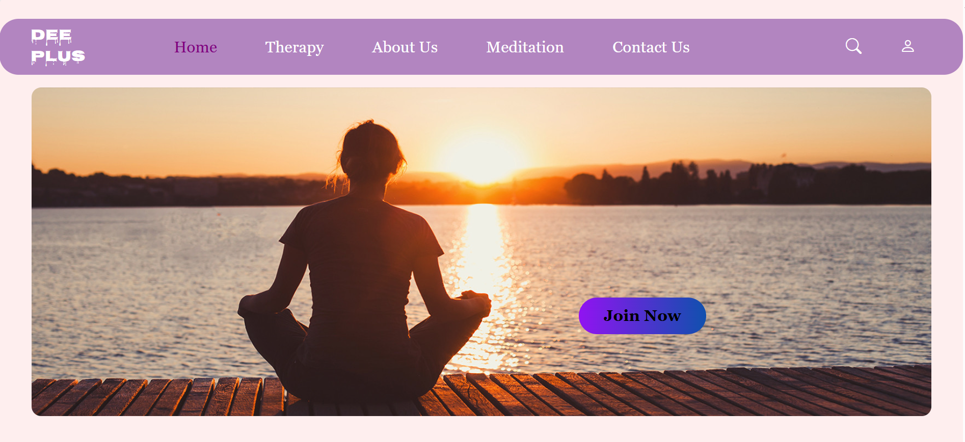

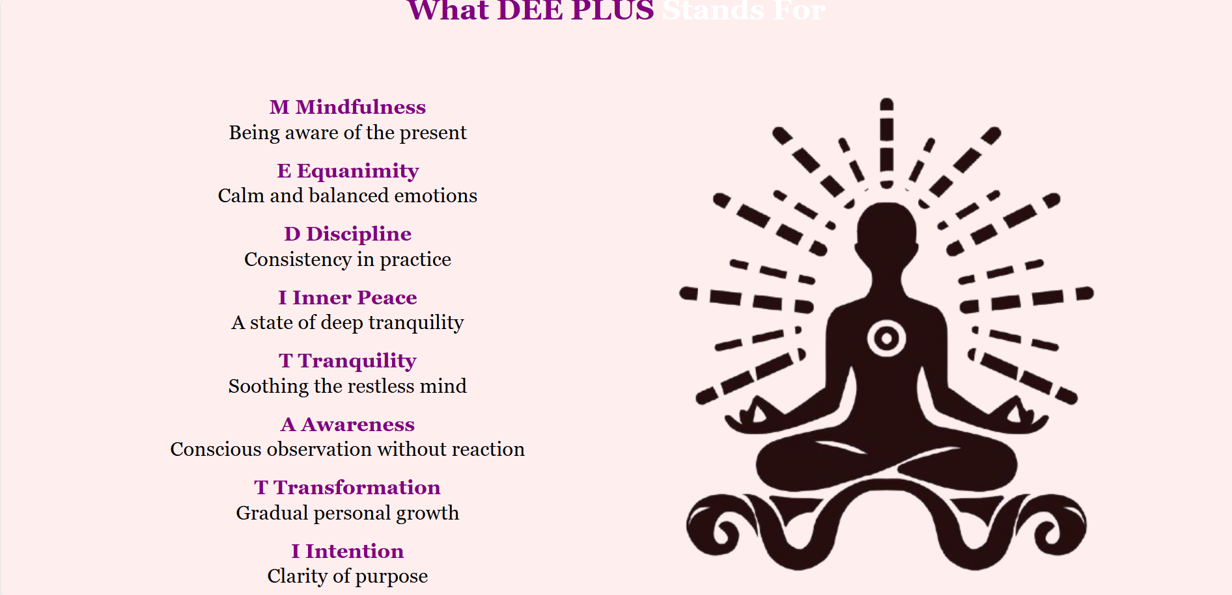

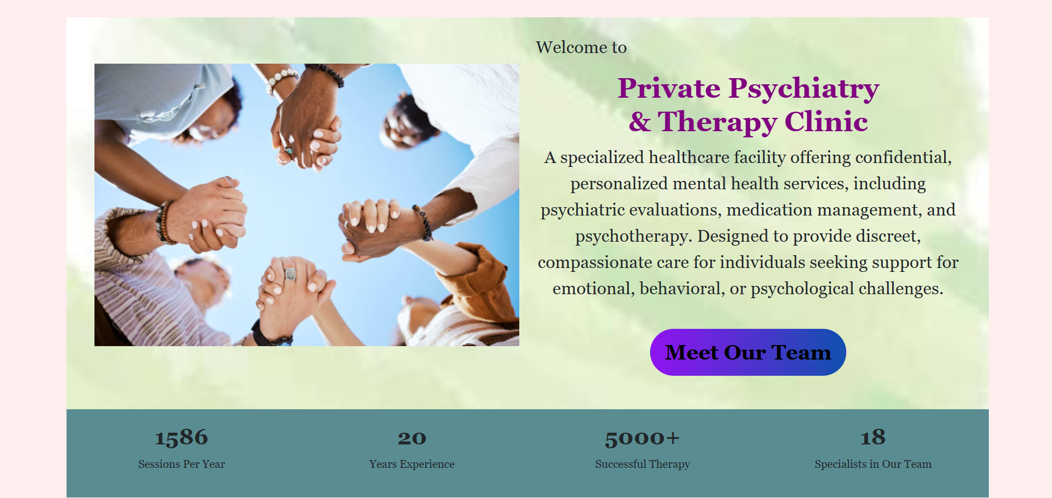

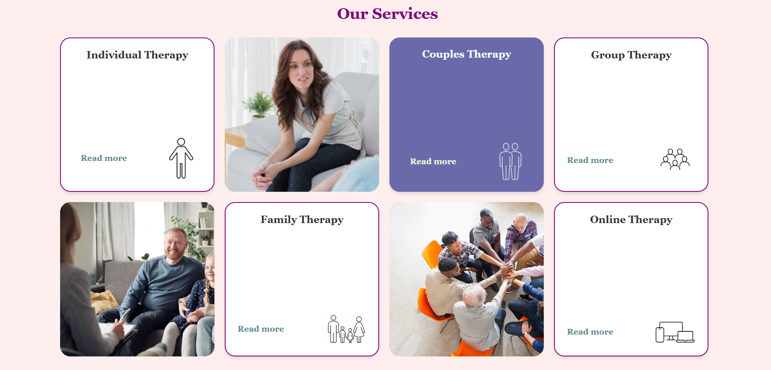

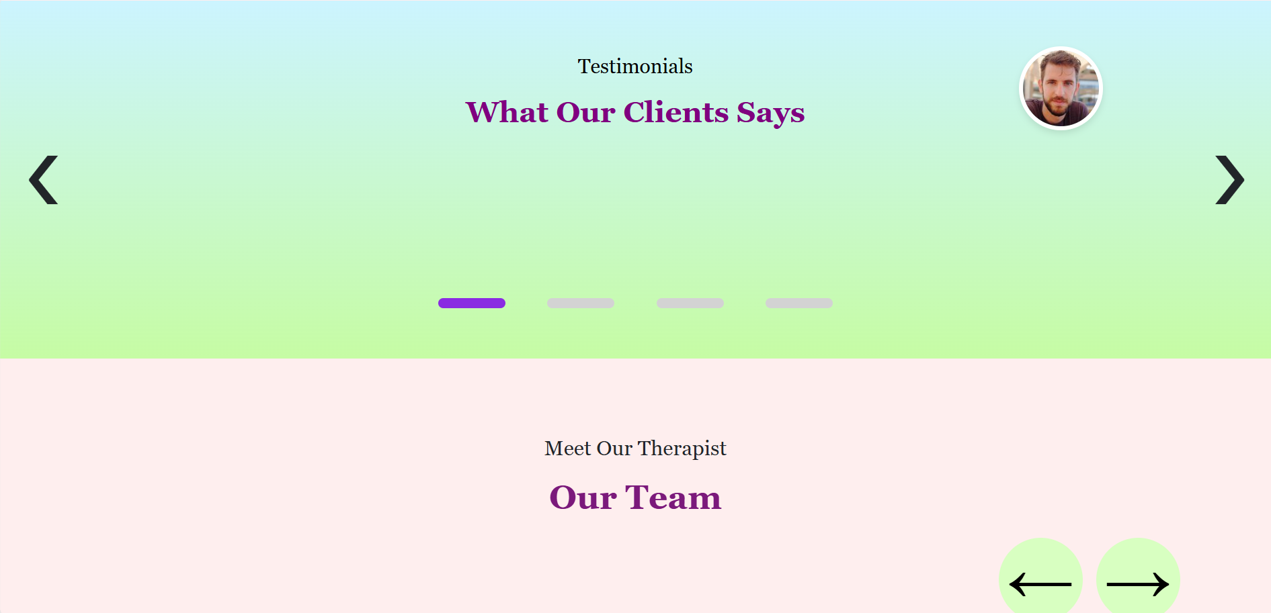

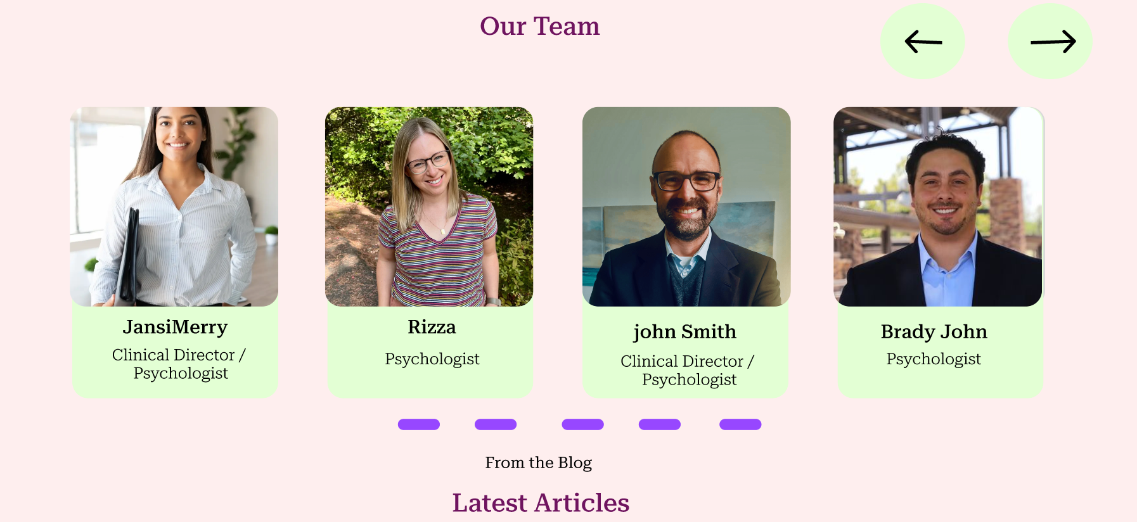

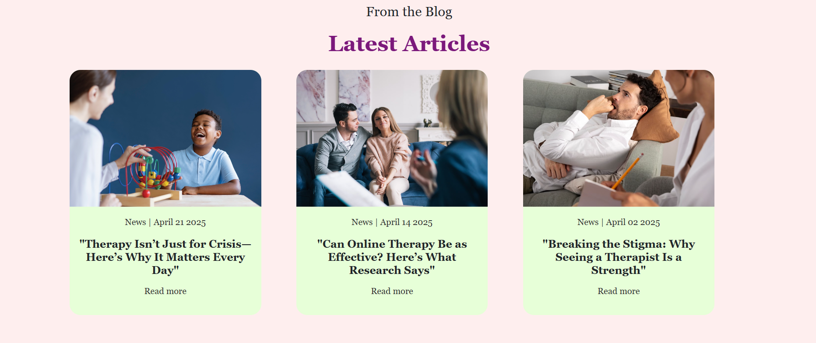

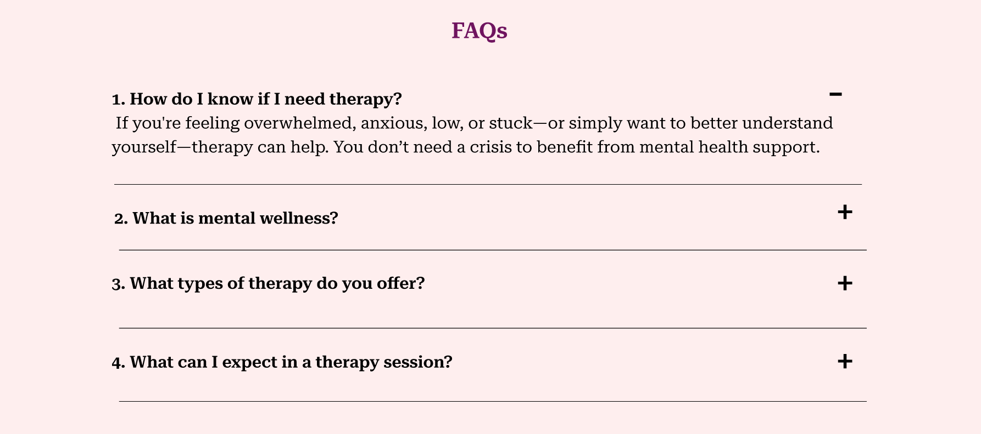

**8. Conclusion**

We ensure To provide a valuable resource of information and downloads to people who want to evolve mentally, emotionally, and spiritually and to help people become healthier, happier and more peaceful.

**Prepared By:** [Vijayalakshmi N]  
**Date:** [24-08-2025]  
**Reviewed By:** [Maheshwaran ]  
**Approved By:** [Maheshwaran]